**INTRODUCTION**

The Sustainable Forestry Initiative® (SFI) [2022 Standards](https://forests.org/sfi-2022-standards/) include requirements that promote and conserve Forests with Exceptional Conservation Value (FECV), which includes critically imperiled (G1) and imperiled (G2) species. This fact sheet summarizes the analysis of FECV habitat within this ecoregion and provides habitat management recommendations that would benefit species potentially found here.

**HABITAT TYPES**

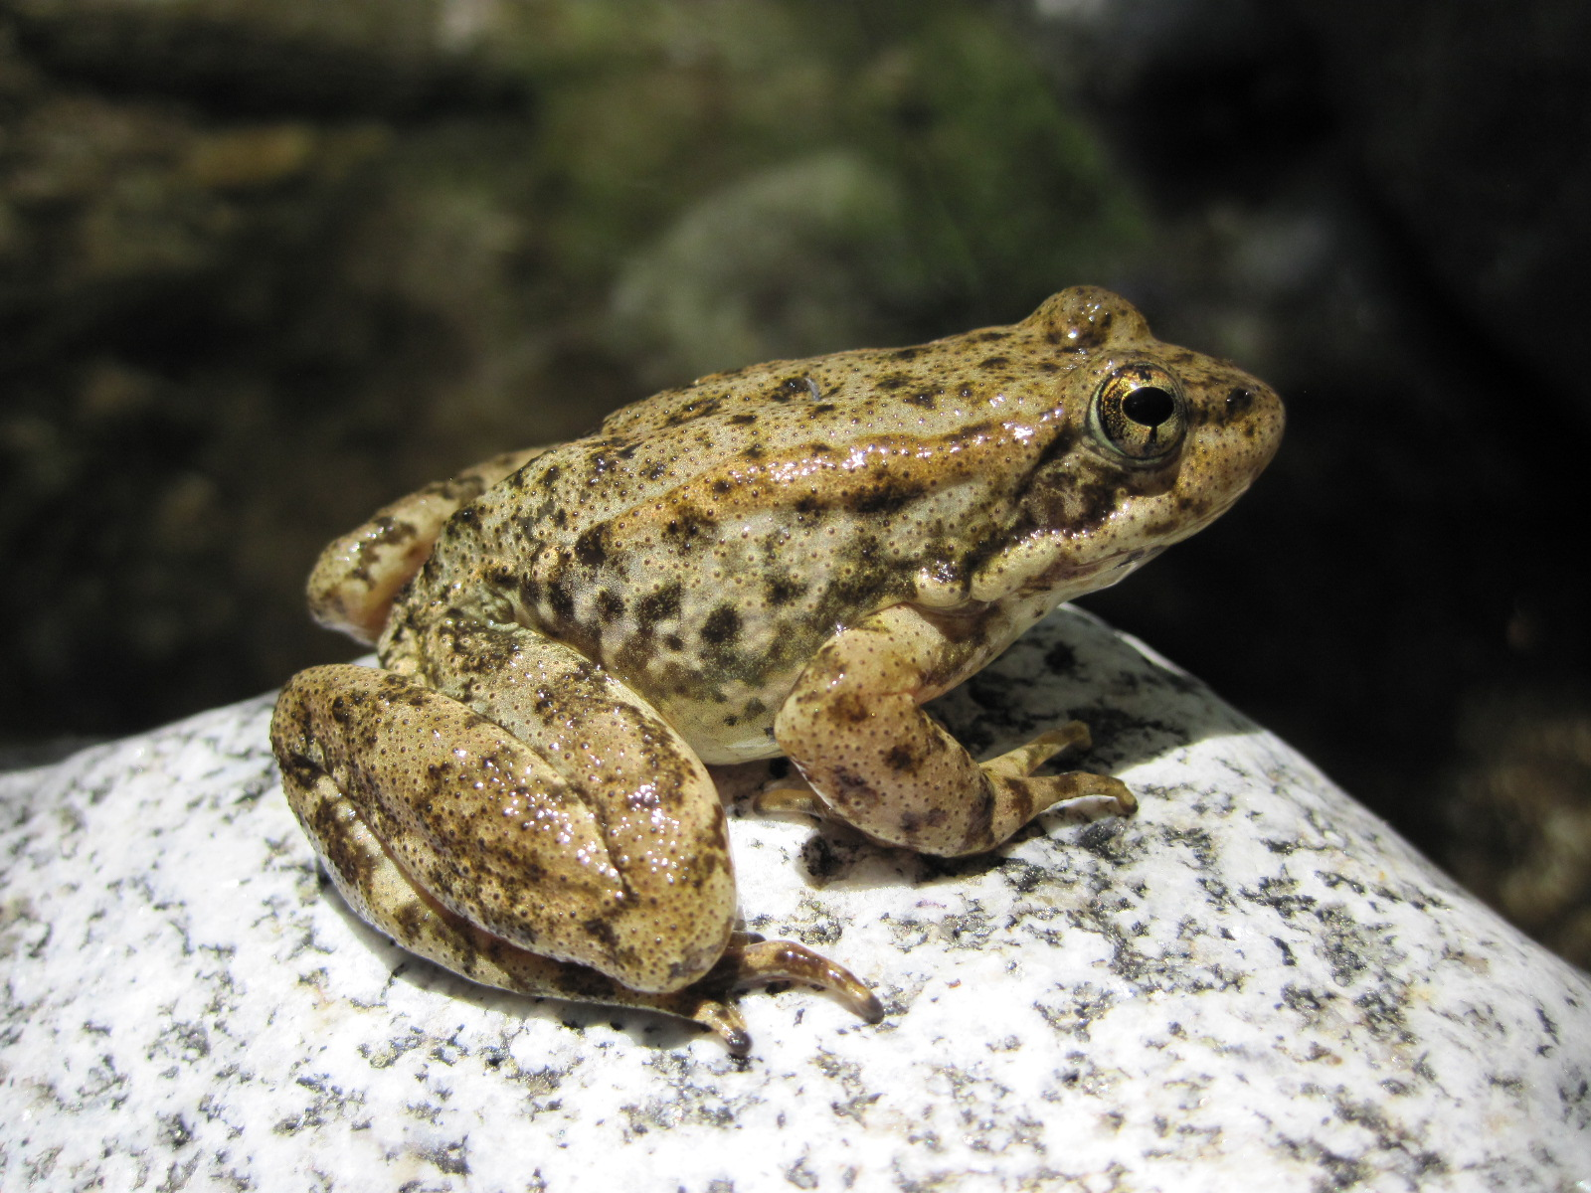

**Southern Mountain Yellow-legged Frog**

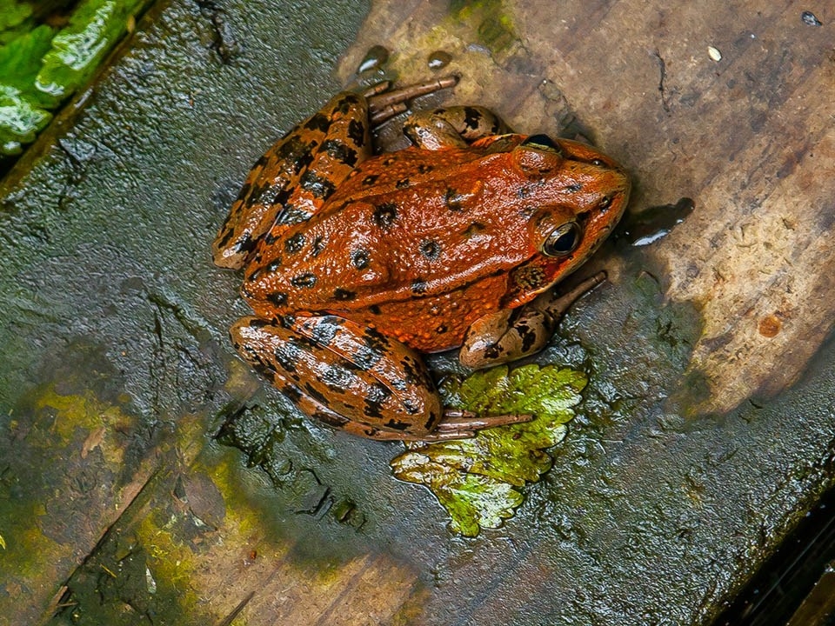

**California Reg-legged Frog**

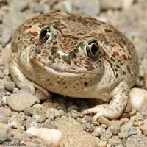**Western Spadefoot**

* Grassland
* Mixed Conifer Forest
* Riparian/Streams/Wetlands/Temporary Pools/Bog/Fen
* Shrubland/Chaparral
* Special Sites (Bare Rock/Talus, Coastal Sage Scrub, Rocky Slopes, Sand/Dune)

**GRASSLAND MANAGEMENT**

* Protect known locations
* Buffer grassland areas

**MIXED CONIFER FOREST MANAGEMENT**

* Protect known locations
* Retain legacy trees, stumps, and logs
* Retain large diameter trees with cavities or broken tops
* Leave skips and gaps with dense shrub component
* Retain large slash into piles

**RIPARIAN/STREAMS/WETLANDS/TEMPORARY POOLS/BOG/FEN MANAGEMENT**

* Protect known locations
* Maintain well vegetated riparian buffers
* Plant a diversity of both hardwood and conifer trees
* Retain large diameter trees near streams, rivers and wetlands
* Buffer wetlands, springs, and headwater areas

**SHRUBLAND/CHAPARRAL MANAGEMENT**

* Protect known locations
* Buffer shrubland and chaparral areas

**SPECIAL SITES MANAGEMENT**

* Protect known locations
* Maintain and buffer special sites

| **SCIENTIFIC NAME** | **COMMON NAME** | **HABITAT** | **STATUS** |
| --- | --- | --- | --- |
| *Hypogymnia schizidiata* | [Island Tube Lichen](https://explorer.natureserve.org/Taxon/ELEMENT_GLOBAL.2.150751) | Bare Rock/Talus | G1 |
| *Tortula californica* | California Screw Moss | Bare Rock/Talus | G2 |
| *Hemizonia minthornii* | [Santa Susana Tarweed](https://explorer.natureserve.org/Taxon/ELEMENT_GLOBAL.2.138357) | Bare Rock/Talus | G2 |
| *Mielichhoferia shevockii* | Shevock's Copper Moss | Bare Rock/Talus | G2 |
| *Arenaria paludicola* | Marsh Sandwort | Bog/Fen | G1 |
| *Dudleya parva* | [Conejo Dudleya](https://explorer.natureserve.org/Taxon/ELEMENT_GLOBAL.2.146554) | Cliff | G1 |
| *Salvia brandegeei* | [Brandegee's Sage](https://explorer.natureserve.org/Taxon/ELEMENT_GLOBAL.2.135735) | Cliff | G2 |
| *Agave shawii* | [Shaw's Agave](https://explorer.natureserve.org/Taxon/ELEMENT_GLOBAL.2.145119) | Cliff | G2 |
| *Bergerocactus emoryi* | [Golden-spined Cereus](https://explorer.natureserve.org/Taxon/ELEMENT_GLOBAL.2.139454) | Coastal Sage Scrub | G2 |
| *Ambrosia pumila* | [San Diego Ragweed](https://explorer.natureserve.org/Taxon/ELEMENT_GLOBAL.2.154697) | Grassland | G1 |
| *Acanthomintha ilicifolia* | [San Diego Thornmint](https://explorer.natureserve.org/Taxon/ELEMENT_GLOBAL.2.151284) | Grassland | G1 |
| *Bombus crotchii* | [Crotch's Bumble Bee](https://explorer.natureserve.org/Taxon/ELEMENT_GLOBAL.2.150751) | Grassland | G2 |
| *Symphyotrichum defoliatum* | [San Bernardino Aster](https://explorer.natureserve.org/Taxon/ELEMENT_GLOBAL.2.150751) | Grassland | G2 |
| [*Navarretia ojaiensis*](https://explorer.natureserve.org/Taxon/ELEMENT_GLOBAL.2.816613) |  | Grassland | G2 |
| *Eriogonum evanidum* | [a buckwheat](https://explorer.natureserve.org/Taxon/ELEMENT_GLOBAL.2.150751) | Mixed Conifer Forest | G1 |
| *Gymnogyps californianus* | California Condor | Mixed Conifer Forest | G1 |
| *Astragalus deanei* | [Deane's Milkvetch](https://explorer.natureserve.org/Taxon/ELEMENT_GLOBAL.2.147831) | Mixed Conifer Forest | G1 |
| *Baccharis malibuensis* | [Malibu Coyote Brush](https://explorer.natureserve.org/Taxon/ELEMENT_GLOBAL.2.156330) | Mixed Conifer Forest | G1 |
| *Helianthus inexpectatus* | [Newhall Sunflower](https://explorer.natureserve.org/Taxon/ELEMENT_GLOBAL.2.858270) | Mixed Conifer Forest | G1 |
| *Arctostaphylos otayensis* | [Otay Manzanita](https://explorer.natureserve.org/Taxon/ELEMENT_GLOBAL.2.138976) | Mixed Conifer Forest | G1 |
| *Cupressus abramsiana* | [Santa Cruz Island Cypress](https://explorer.natureserve.org/Taxon/ELEMENT_GLOBAL.2.161494) | Mixed Conifer Forest | G1 |
| *Pinus torreyana* | [Torrey Pine](https://explorer.natureserve.org/Taxon/ELEMENT_GLOBAL.2.147567) | Mixed Conifer Forest | G1 |
| *Dudleya verityi* | [Verity's Dudleya](https://explorer.natureserve.org/Taxon/ELEMENT_GLOBAL.2.160573) | Mixed Conifer Forest | G1 |
| *Scrophularia atrata* | [Black-flower Figwort](https://explorer.natureserve.org/Taxon/ELEMENT_GLOBAL.2.141740) | Mixed Conifer Forest | G2 |
| *Calochortus dunnii* | [Dunn's Mariposa Lily](https://explorer.natureserve.org/Taxon/ELEMENT_GLOBAL.2.144933) | Mixed Conifer Forest | G2 |
| *Cupressus goveniana* | [Gowen Cypress](https://explorer.natureserve.org/Taxon/ELEMENT_GLOBAL.2.144274) | Mixed Conifer Forest | G2 |
| *Symphyotrichum greatae* | [Greata's Aster](https://explorer.natureserve.org/Taxon/ELEMENT_GLOBAL.2.144274) | Mixed Conifer Forest | G2 |
| *Fremontodendron mexicanum* | [Mexican Flannelbush](https://explorer.natureserve.org/Taxon/ELEMENT_GLOBAL.2.148726) | Mixed Conifer Forest | G2 |
| *Navarretia setiloba* | Piute Mountains Navarretia | Mixed Conifer Forest | G2 |
| *Ceanothus cyaneus* | [San Diego Ceanothus](https://explorer.natureserve.org/Taxon/ELEMENT_GLOBAL.2.142474) | Mixed Conifer Forest | G2 |
| *Astragalus oocarpus* | [San Diego Milkvetch](https://explorer.natureserve.org/Taxon/ELEMENT_GLOBAL.2.109555) | Mixed Conifer Forest | G2 |
| *Glyptostoma gabrielense* | [San Gabriel Chestnut](https://explorer.natureserve.org/Taxon/ELEMENT_GLOBAL.2.111204) | Mixed Conifer Forest | G2 |
| *Cupressus forbesii* | [Tecate Cypress](https://explorer.natureserve.org/Taxon/ELEMENT_GLOBAL.2.131138) | Mixed Conifer Forest | G2 |
| *Dudleya variegata* | [Variegated Dudleya](https://explorer.natureserve.org/Taxon/ELEMENT_GLOBAL.2.131714) | Mixed Conifer Forest | G2 |
| [*Thysanocarpus rigidus*](https://explorer.natureserve.org/Taxon/ELEMENT_GLOBAL.2.860023) |  | Mixed Conifer Forest | G2 |
| *Monardella stoneana* | [Jennifer's Monardella](https://explorer.natureserve.org/Taxon/ELEMENT_GLOBAL.2.737191) | Riparian/Streams | G1 |
| *Catostomus santaanae* | [Santa Ana Sucker](https://explorer.natureserve.org/Taxon/ELEMENT_GLOBAL.2.103583) | Riparian/Streams | G1 |
| *Rana muscosa* | Southern Mountain Yellow-legged Frog | Riparian/Streams | G1 |
| *Gila orcuttii* | Arroyo Chub | Riparian/Streams | G2 |
| *Anaxyrus californicus* | Arroyo Toad | Riparian/Streams | G2 |
| *Linderiella occidentalis* | California Fairy Shrimp | Riparian/Streams | G2 |
| *Rana draytonii* | California Red-legged Frog | Riparian/Streams | G2 |
| *Malacothamnus davidsonii* | Davidson's Bushmallow | Riparian/Streams | G2 |
| *Navarretia prostrata* | Prostrate Navarretia | Riparian/Streams | G2 |
| *Clinopodium chandleri* | [San Miguel Savory](https://explorer.natureserve.org/Taxon/ELEMENT_GLOBAL.2.152210) | Riparian/Streams | G2 |
| *Hemizonia floribunda* | [Tecate Tarweed](https://explorer.natureserve.org/Taxon/ELEMENT_GLOBAL.2.159305) | Riparian/Streams | G2 |
| *Spea hammondii* | Western Spadefoot | Riparian/Streams | G2 |
| *Ceanothus verrucosus* | [Warty-stem Ceanothus](https://explorer.natureserve.org/Taxon/ELEMENT_GLOBAL.2.146876) | Rocky Slopes | G2 |
| *Triquetrella californica* | [California Triquetrella Moss](https://explorer.natureserve.org/Taxon/ELEMENT_GLOBAL.2.126131) | Sand/Dune | G2 |
| *Orcuttia californica* | [California Orcutt Grass](https://explorer.natureserve.org/Taxon/ELEMENT_GLOBAL.2.134354) | Shrubland/Chaparral | G1 |
| *Eriogonum crocatum* | [Conejo Buckwheat](https://explorer.natureserve.org/Taxon/ELEMENT_GLOBAL.2.149148) | Shrubland/Chaparral | G1 |
| *Baccharis vanessae* | [Encinitis Baccharis](https://explorer.natureserve.org/Taxon/ELEMENT_GLOBAL.2.157399) | Shrubland/Chaparral | G1 |
| *Tharsalea hermes* | [Hermes Copper](https://explorer.natureserve.org/Taxon/ELEMENT_GLOBAL.2.115329) | Shrubland/Chaparral | G1 |
| *Dudleya stolonifera* | [Laguna Beach Dudleya](https://explorer.natureserve.org/Taxon/ELEMENT_GLOBAL.2.144868) | Shrubland/chaparral | G1 |
| *Berberis nevinii* | [Nevin's Barberry](https://explorer.natureserve.org/Taxon/ELEMENT_GLOBAL.2.146118) | Shrubland/Chaparral | G1 |
| *Hazardia orcuttii* | [Orcutt's Hazardia](https://explorer.natureserve.org/Taxon/ELEMENT_GLOBAL.2.154810) | Shrubland/Chaparral | G1 |
| *Ceanothus otayensis* | [Otay Mountain Ceanothus](https://explorer.natureserve.org/Taxon/ELEMENT_GLOBAL.2.129052) | Shrubland/Chaparral | G1 |
| *Atriplex parishii* | Parish's Saltbush | Shrubland/Chaparral | G1 |
| *Cercocarpus traskiae* | [Santa Catalina Mountain-mahogany](https://explorer.natureserve.org/Taxon/ELEMENT_GLOBAL.2.142253) | Shrubland/Chaparral | G1 |
| *Trimerotropis occidentiloides* | [Santa Monica Grasshopper](https://explorer.natureserve.org/Taxon/ELEMENT_GLOBAL.2.113651) | Shrubland/Chaparral | G1 |
| *Ceanothus ophiochilus* | [Vail Lake Ceanothus](https://explorer.natureserve.org/Taxon/ELEMENT_GLOBAL.2.129759) | Shrubland/Chaparral | G1 |
| [*Ceanothus pendletonensis*](https://explorer.natureserve.org/Taxon/ELEMENT_GLOBAL.2.1095123) |  | Shrubland/Chaparral | G1 |
| *Astragalus brauntonii* | [Braunton's Milkvetch](https://explorer.natureserve.org/Taxon/ELEMENT_GLOBAL.2.156760) | Shrubland/Chaparral | G2 |
| *Quercus cedrosensis* | [Cedros Island Oak](https://explorer.natureserve.org/Taxon/ELEMENT_GLOBAL.2.147634) | Shrubland/Chaparral | G2 |
| *Nolina interrata* | [Dehesa (San Diego) Bear-grass](https://explorer.natureserve.org/Taxon/ELEMENT_GLOBAL.2.138817) | Shrubland/Chaparral | G2 |
| *Linanthus bellus* | [Desert Beauty](https://explorer.natureserve.org/Taxon/ELEMENT_GLOBAL.2.142484) | Shrubland/Chaparral | G2 |
| *Packera ganderi* | [Gander's Ragwort](https://explorer.natureserve.org/Taxon/ELEMENT_GLOBAL.2.140498) | Shrubland/Chaparral | G2 |
| *Lepechinia cardiophylla* | [Heart-shaped Pitcher-sage](https://explorer.natureserve.org/Taxon/ELEMENT_GLOBAL.2.140498) | Shrubland/Chaparral | G2 |
| *Galium buxifolium* | [Island Bedstraw](https://explorer.natureserve.org/Taxon/ELEMENT_GLOBAL.2.152560) | Shrubland/Chaparral | G2 |
| *Ribes canthariforme* | [Moreno Currant](https://explorer.natureserve.org/Taxon/ELEMENT_GLOBAL.2.130903) | Shrubland/Chaparral | G2 |
| *Arctostaphylos rainbowensis* | [Rainbow Manzanita](https://explorer.natureserve.org/Taxon/ELEMENT_GLOBAL.2.131451) | Shrubland/Chaparral | G2 |
| *Muilla clevelandii* | [San Diego Goldenstar](https://explorer.natureserve.org/Taxon/ELEMENT_GLOBAL.2.146812) | Shrubland/Chaparral | G2 |
| *Ribes viburnifolium* | [Santa Catalina Island Currant](https://explorer.natureserve.org/Taxon/ELEMENT_GLOBAL.2.137136) | Shrubland/Chaparral | G2 |
| *Perognathus alticola* | [White-eared Pocket Mouse](https://explorer.natureserve.org/Taxon/ELEMENT_GLOBAL.2.101896) | Shrubland/Chaparral | G2 |
| *Pogogyne nudiuscula* | Otay Manzanita | Temporary Pools | G1 |
| *Streptocephalus woottoni* | [Riverside Fairy Shrimp](https://explorer.natureserve.org/Taxon/ELEMENT_GLOBAL.2.110736) | Temporary Pools | G1 |
| *Brodiaea orcuttii* | [Orcutt's Brodiaea](https://explorer.natureserve.org/Taxon/ELEMENT_GLOBAL.2.129441) | Temporary Pools | G2 |
| *Branchinecta sandiegonensis* | [San Diego Fairy Shrimp](https://explorer.natureserve.org/Taxon/ELEMENT_GLOBAL.2.113643) | Temporary Pools | G2 |
| *Navarretia fossalis* | Spreading Navarretia | Temporary Pools | G2 |
| *Diplectrona californica* | [California Diplectronan Caddisfly](https://explorer.natureserve.org/Taxon/ELEMENT_GLOBAL.2.120809) | Wetland | G1 |
| *Calystegia felix* | [Lucky Morning Glory](https://explorer.natureserve.org/Taxon/ELEMENT_GLOBAL.2.148092) | Wetland | G1 |
| *Tryonia imitator* | [Mimic Tryonia](https://explorer.natureserve.org/Taxon/ELEMENT_GLOBAL.2.148092) | Wetland | G2 |

*\*Species links provided when available*